# CS 255 System Design Document Template

## UML Diagrams

### UML Use Case Diagram

### UML Activity Diagrams

### UML Sequence Diagram

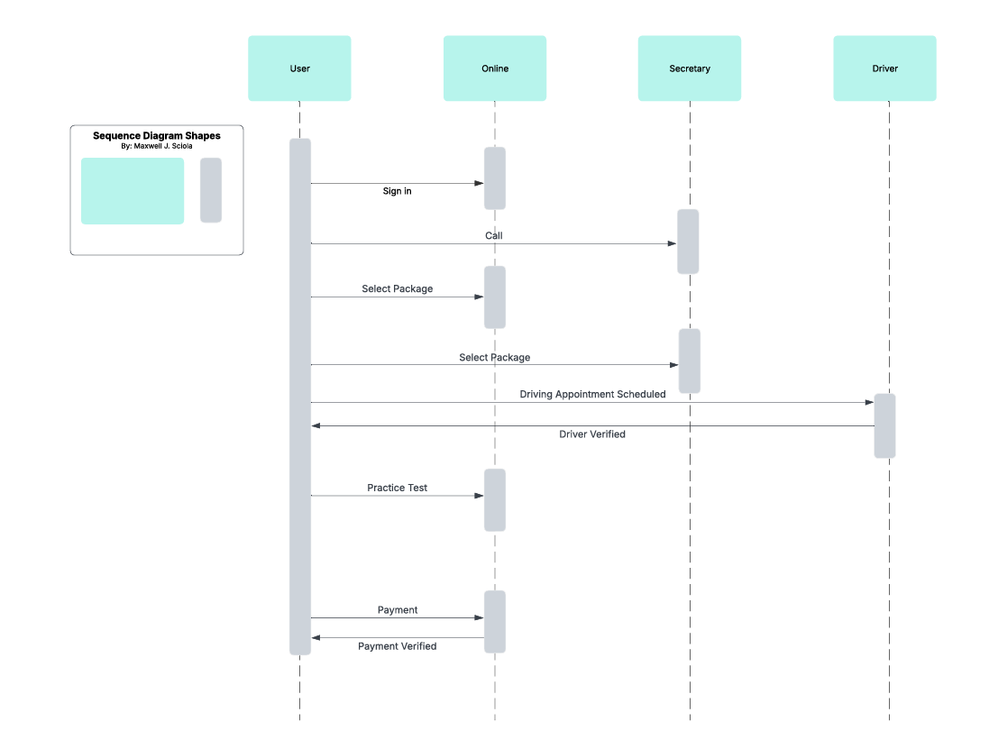

### UML Class Diagram

## Technical Requirements

A user will need a computer that can run a simple web interface. We recommend completing all hardware updates and installing the latest web browser version. For example, the user should install a minimum of Windows 10, macOS Catalina, or Ubuntu 20.04 to handle all the interface features smoothly. Admin and IT personnel may require higher-spec devices, such as machines with at least 16 GB of RAM, a multi-core processor, and SSD storage to support development tools and customer service platforms.

The software requirements for DriverPass include web browsers such as Google Chrome, Mozilla Firefox, or Microsoft Edge so that users can access the platform efficiently. On the server side, the backend will run on a stable Linux distribution such as Ubuntu Server. It will use frameworks like Node.js or Spring Boot for backend APIs and a relational database such as MySQL or PostgreSQL to store user and transaction data. Additionally, integration with secure payment processing tools like Stripe or PayPal will allow for smooth and safe financial transactions.

Security is another important technical requirement. Due to DriverPass requiring sensitive information from the client, security is a top priority when handling personal and credit card information. All data transmission will be protected using SSL encryption, and the system will require strong, unique passwords and two-step authentication for all users, especially administrators and IT staff. Furthermore, role-based access control will help limit system privileges to only those who need them. In case of a cyberattack or the system fails, we will conduct regular patching and vulnerability scans and have encrypted cloud backups to make DriverPass as secure as possible.

Development and maintenance of the backend are critical to the system's success. To enhance the user experience, a full-time developer will frequently update the interface and make improvements. To create and support an efficient Agile development team, Git will be used for version control, Eclipse for development, and Jira for project management. Regarding customer support, the tool Intercom will ensure users get timely and helpful assistance from the administrators.

Google Cloud Platform will be used to host those components, providing security and ensuring scalability to the DriverPass system. We will also conduct automated backups on a daily basis to protect data integrity. Since system diagrams focus on functional workflow, these technical requirements were not visible within them. The IT team, along with the administrative staff, will be responsible for maintaining the system and supporting its growth.